# **AWS**

# 

# **RDS Database Backup and Recovery with AWS Backup**

Step 1 : login to aws management console and navigate to RDS console.

Step 2 : Create a RDS database here we choose MySql database with “disable automatic backup and encryption” ,you can choose as your own ,and rest all the settings are by default .

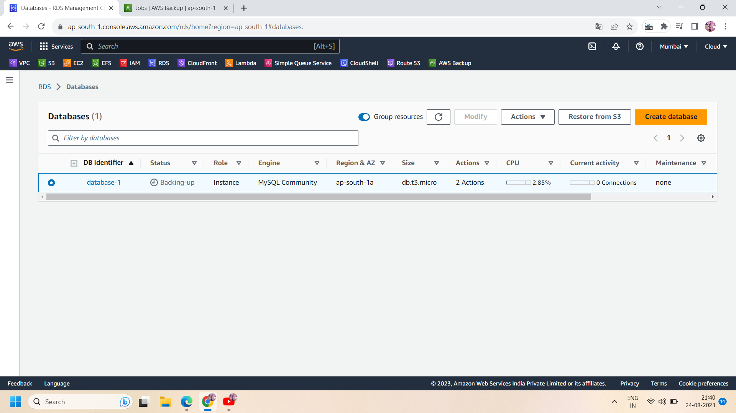

Step 3: now go to AWS backup dashboard and create a “on-demand backup”.to create a on-demand backup:

* Select the resource type as “RDS” and select your database as “database name”.
* Select the backup window as “create backup now”.
* Select the retention period as per your requirement.here we chose fpr 1 day
* Select the default vault or create a new vault.
* Select the default IAM role.
* Then click on “create on-demand backup”

Step 4: now a backup job will start creating for your RDS resource.

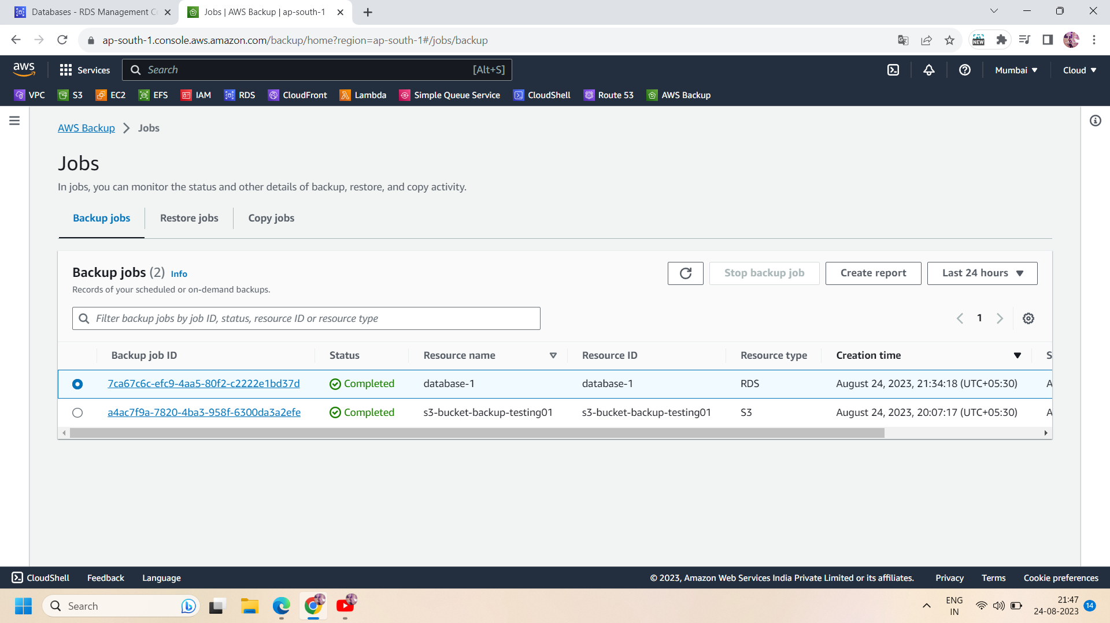

Step 5: when the backup job status changes to “complete”,delete the RDS database to restore it using AWS backup.

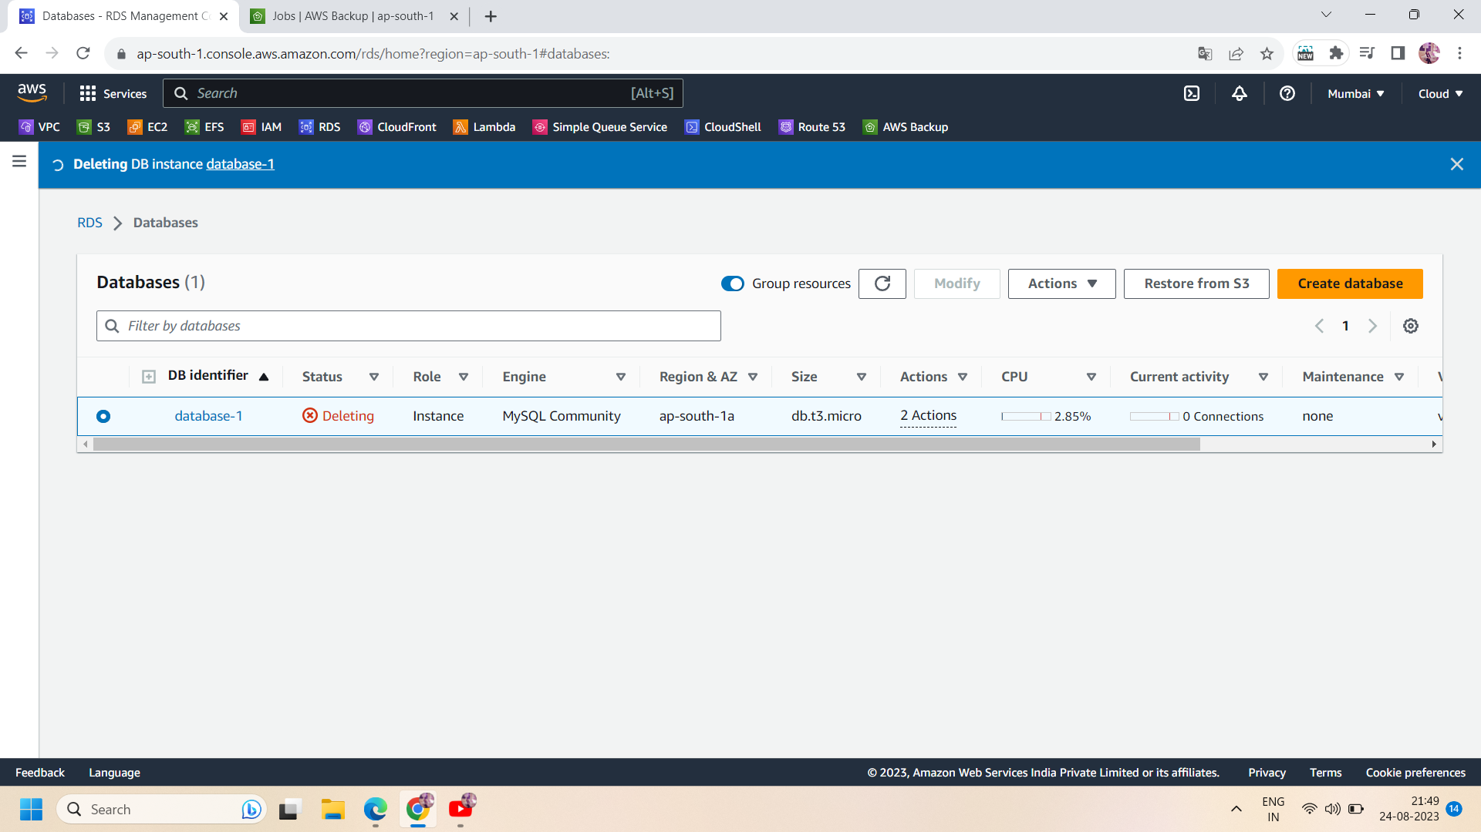

Step 6: After deleting the RDS database,go to “backup vault” and select your database in recovery points and se;lect the “restore” in actions.

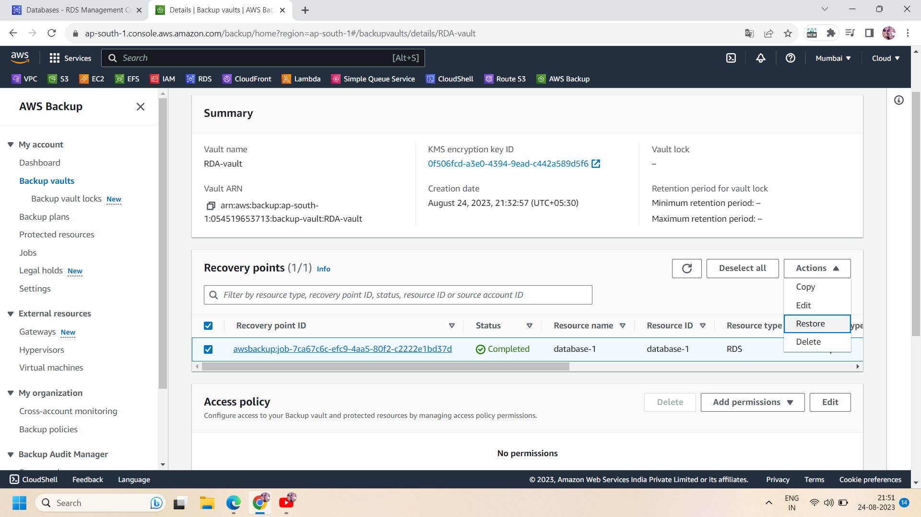

Step 7:To restore the database,name the restore database in “DB instance identifier” and we leave rest of the settings by default but you can change them just like DB instance class,its availability or durability.then click on “restore backup”.

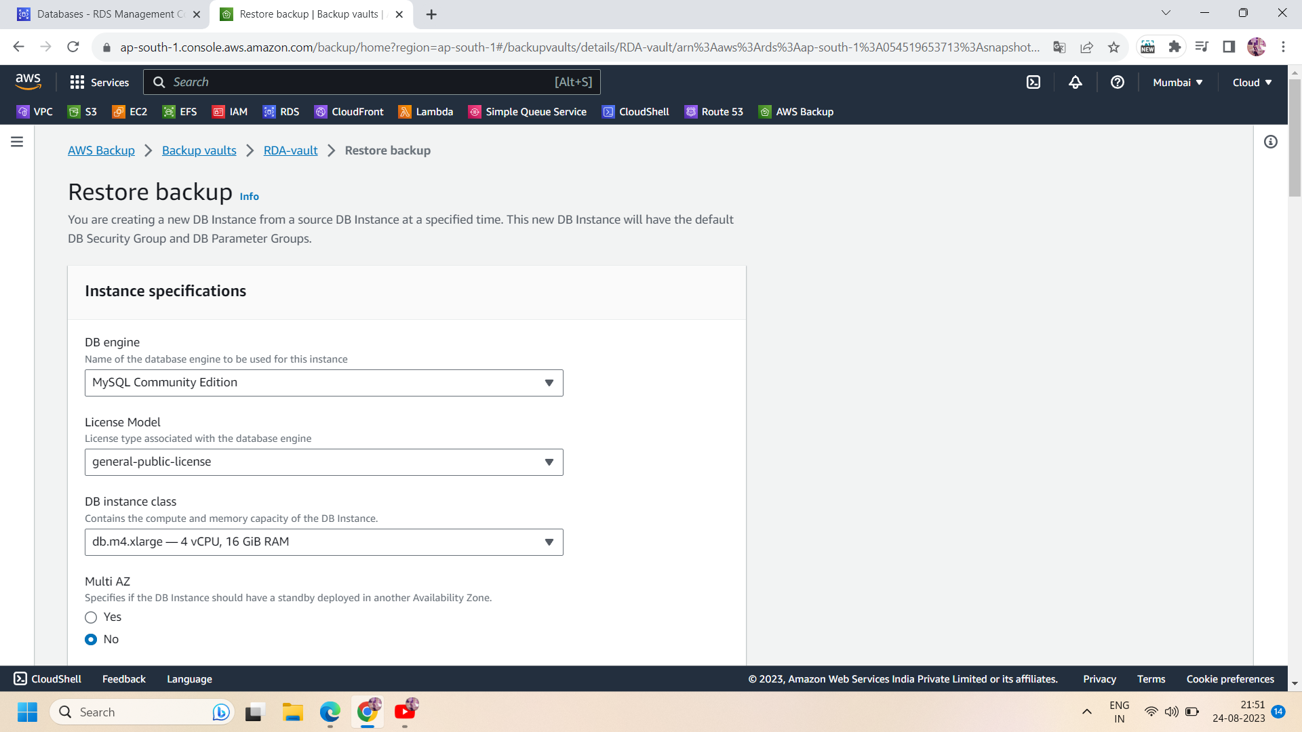

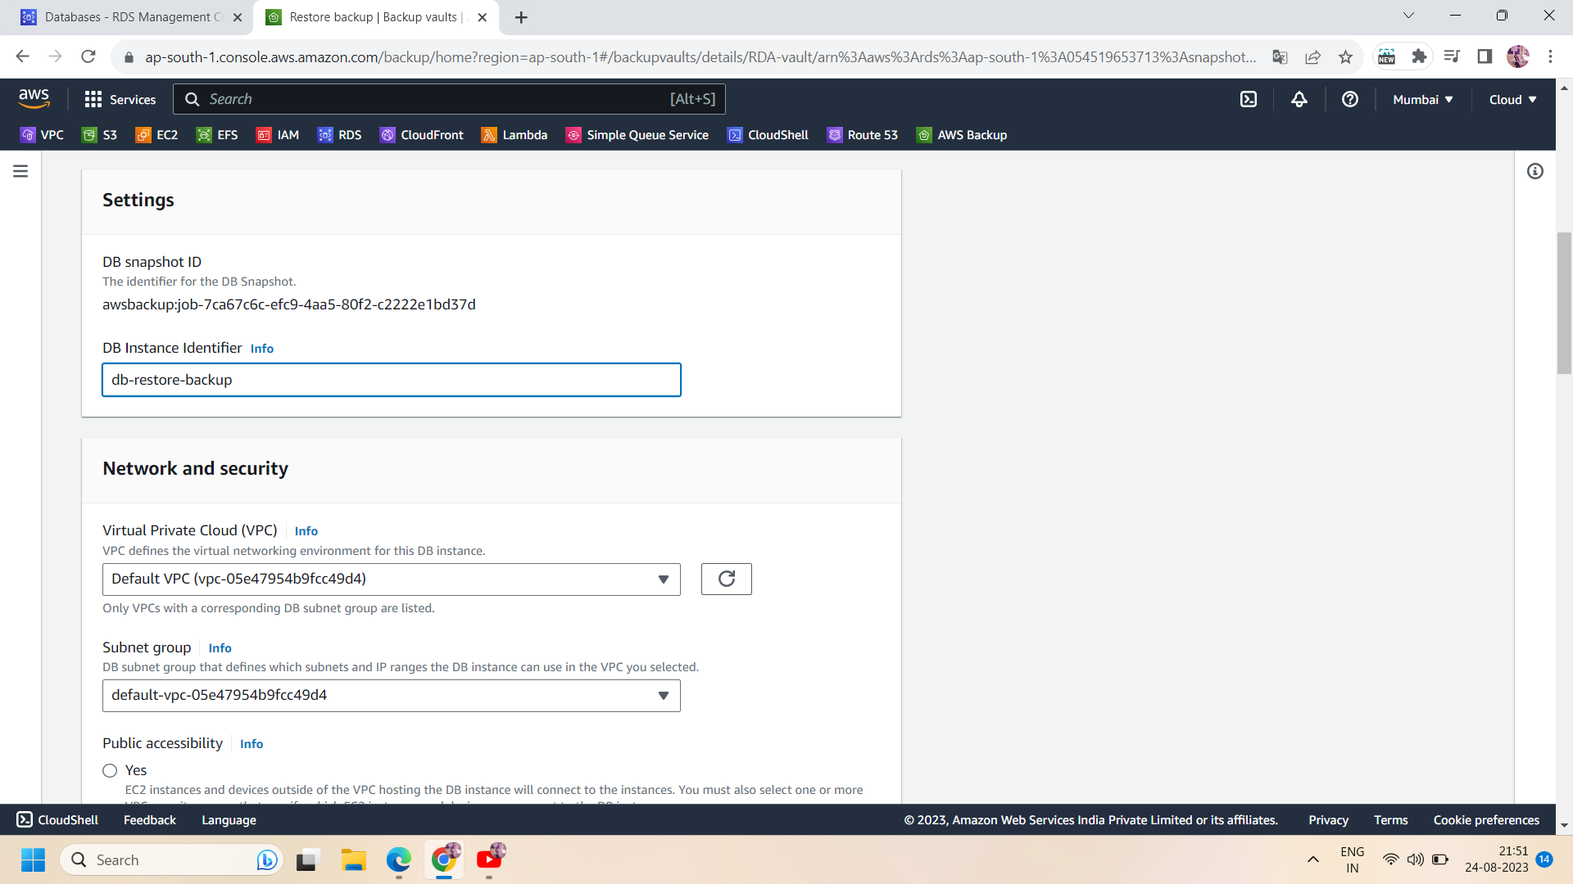

Step 8:Now the restore job will start creating ,you can check it in the backup job section.when the restore job is complete,you can access it in the RDS dashboard too.IT will be available in the RDS section.

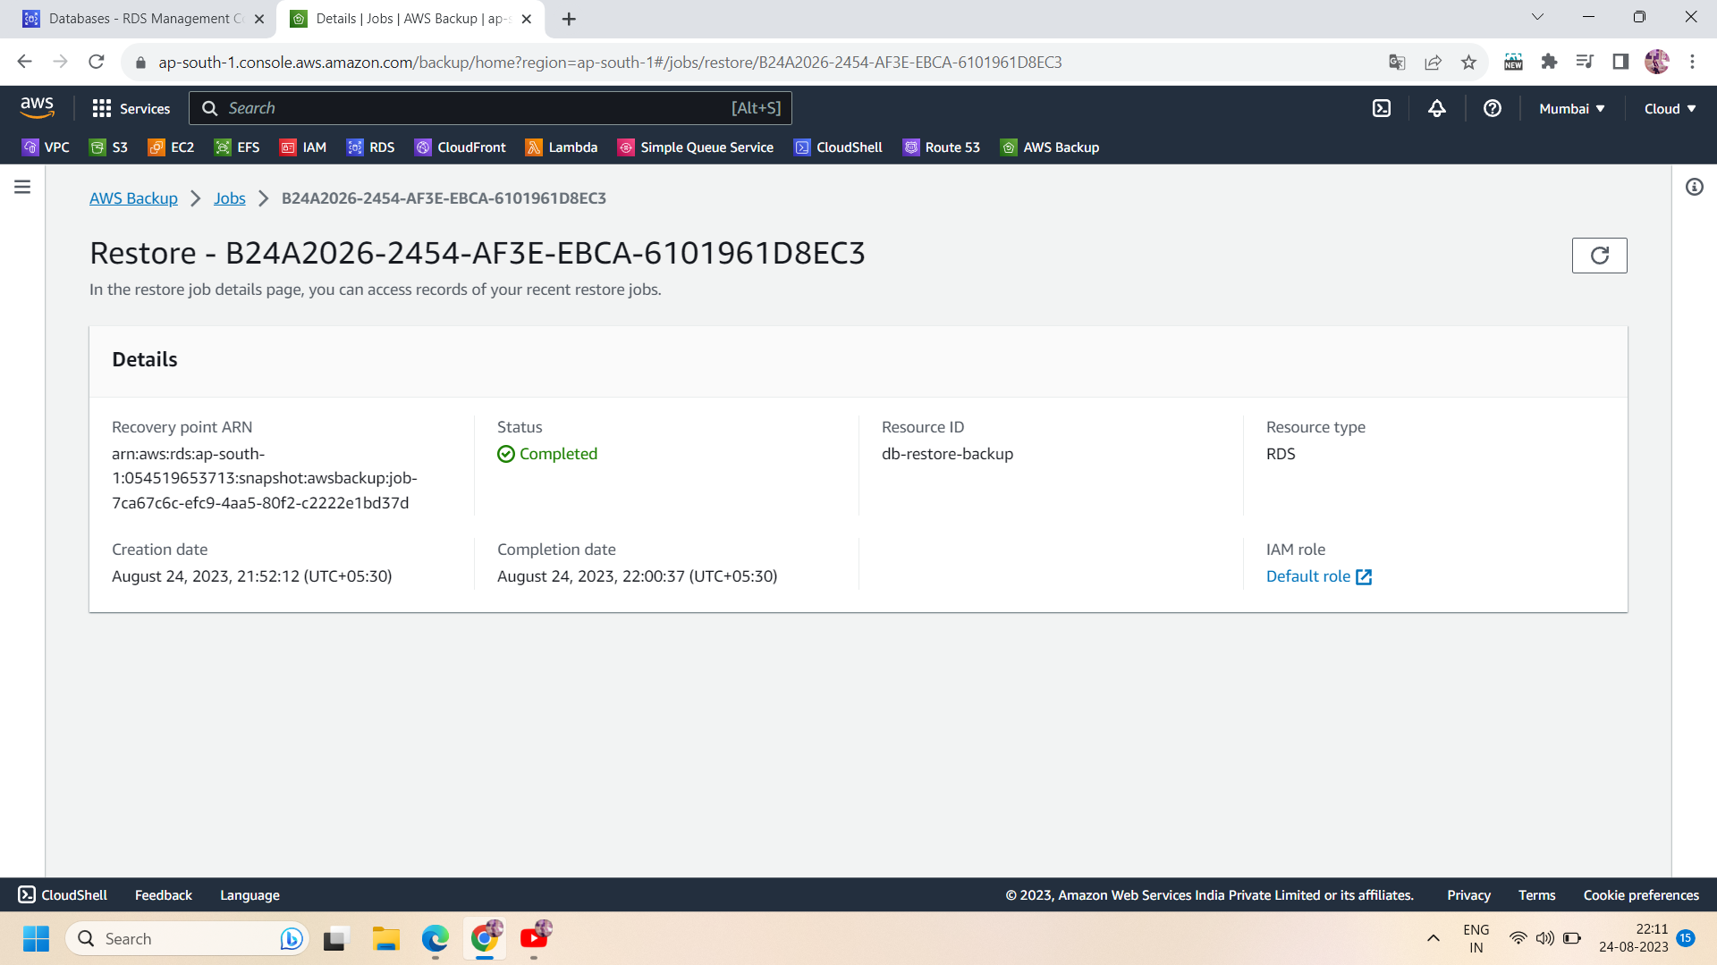

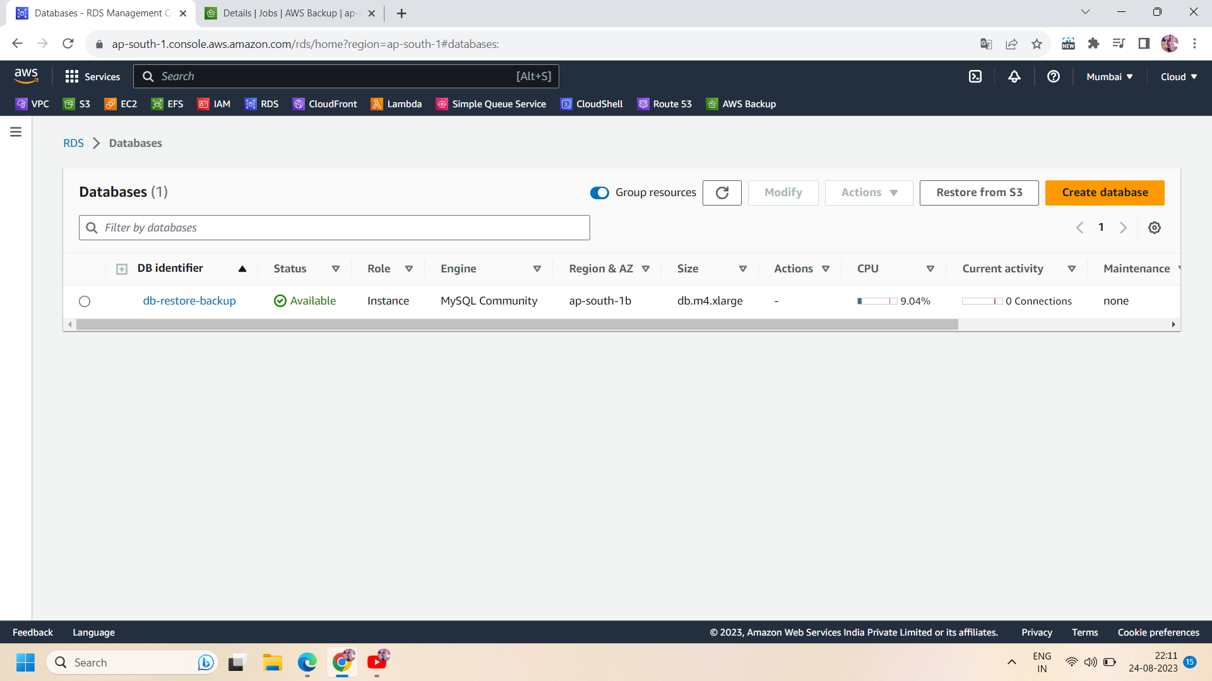

All done!!